◆ Platform User Guide — Academic Deputy ◆
For: the academic deputy — who alone assigns peer teachers
You have everything the principal has, and one thing more: assigning peers. Until you assign a visit, it does not appear in the peer teacher's account, and the peer card is never filled at all.
Before you start — four things that concern everyone
1. Open the link — https://ahseyam.github.io/unified-lesson/
2. Switch to English — the EN button, top right
3. Choose your role — one card per role
4. Enter your staff number — you are identified by it, not by your name

• Open the link: It runs on phone, laptop and tablet with nothing to install. Bookmark it — it is your single reference; do not rely on a copy someone sends you, or you will be working from yesterday's data.
• Switch to English: Press it once and the choice is remembered on your device. Arabic is the default for everyone, so nothing changes for your Arabic-speaking colleagues. You may enter your own text in English or Arabic — both are kept as typed.
• Choose your role: Each role sees only what concerns it: its own buttons, screens and reports. You will not see what is not yours, and you cannot press a button that destroys someone else's work.
• Enter your staff number: Names repeat and are spelled in different ways, so the same person appears twice in the reports. If your number is on the roster, your name and subject are filled in for you.
❖ Step by step — with pictures every screenshot is taken from the platform itself, not drawn or imagined
1 Sign in and choose your school
• Choose the “Academic deputy” card, then the sector, the complex and the school.
• It is fixed for you, exactly as it is for the principal.
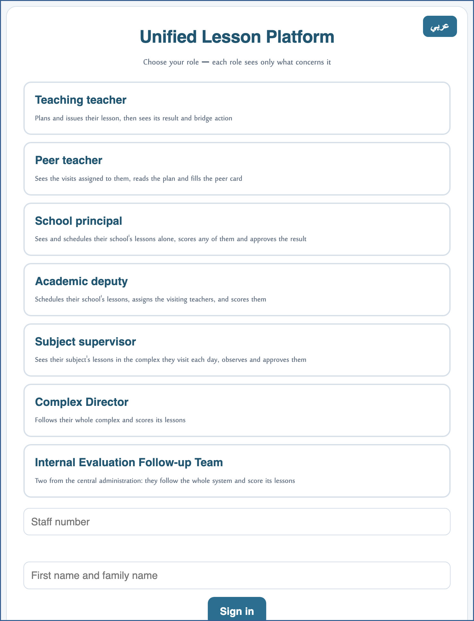
A live screenshot of the platform itself
2 Check the schedule is complete
• Before assigning: make sure the lessons carry their teachers' names in the cells.
• No assignment can be made on a cell with no teacher.
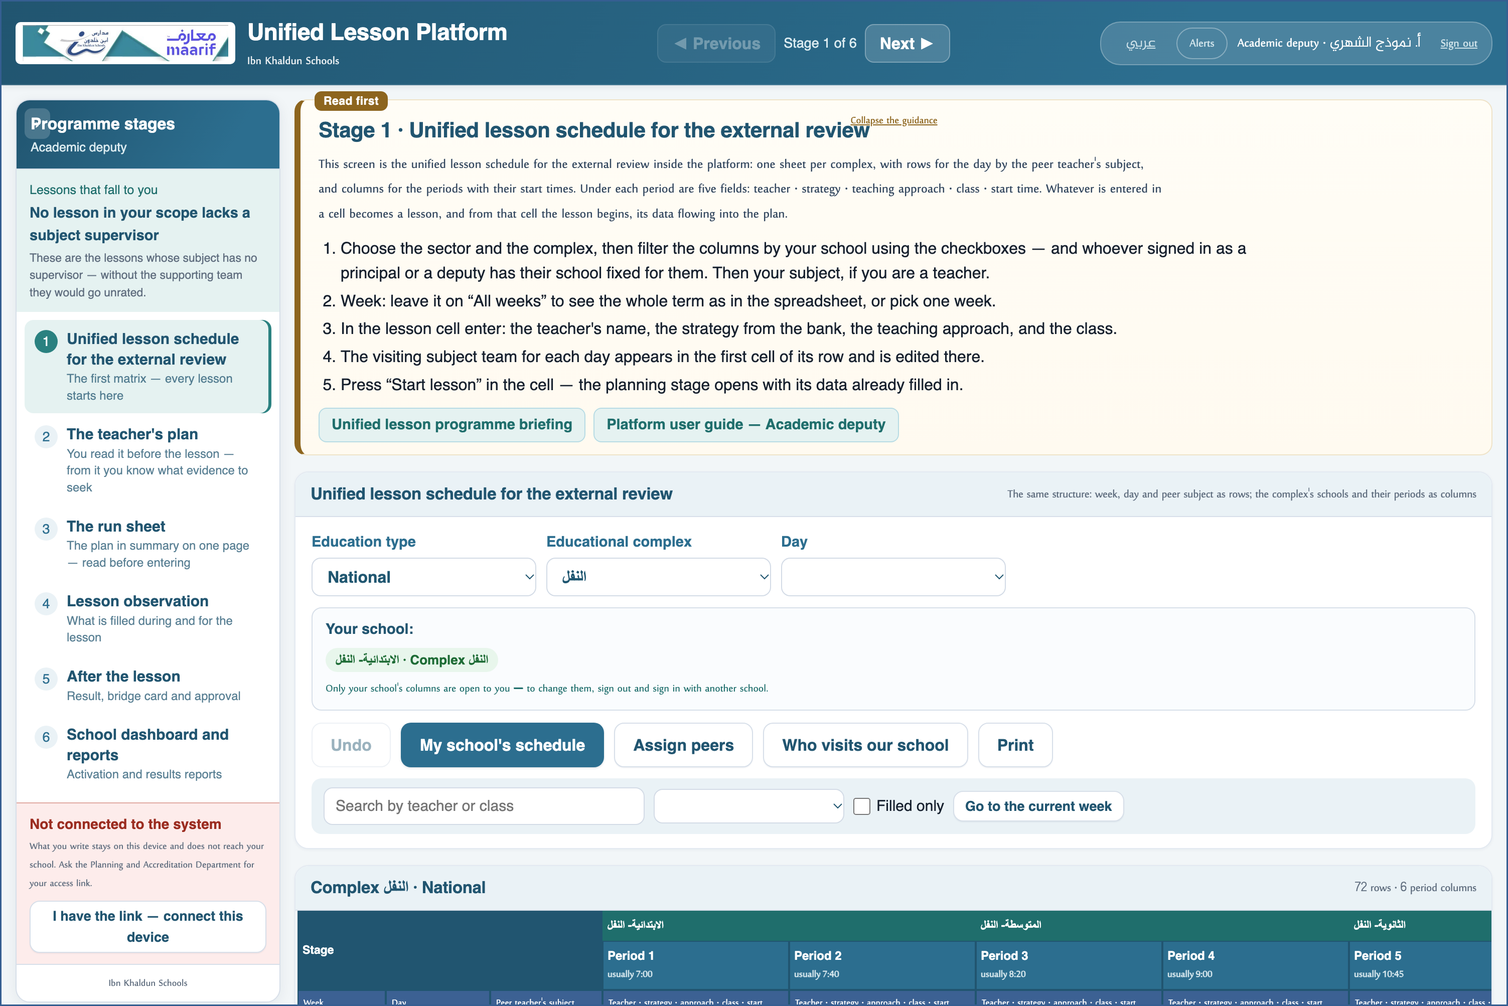
A live screenshot of the platform itself
3 See who has not entered before you assign
• Above the schedule a line reads: “N of the roster with no lesson yet” — with an “Open the roster” button.
• The list names them by name, staff number and subject, and prints or exports as CSV.
• Follow them up first: the schedule is not complete without them.
⛔ The report measures the schedule against the teacher roster, not against itself — so whoever has not entered is named.

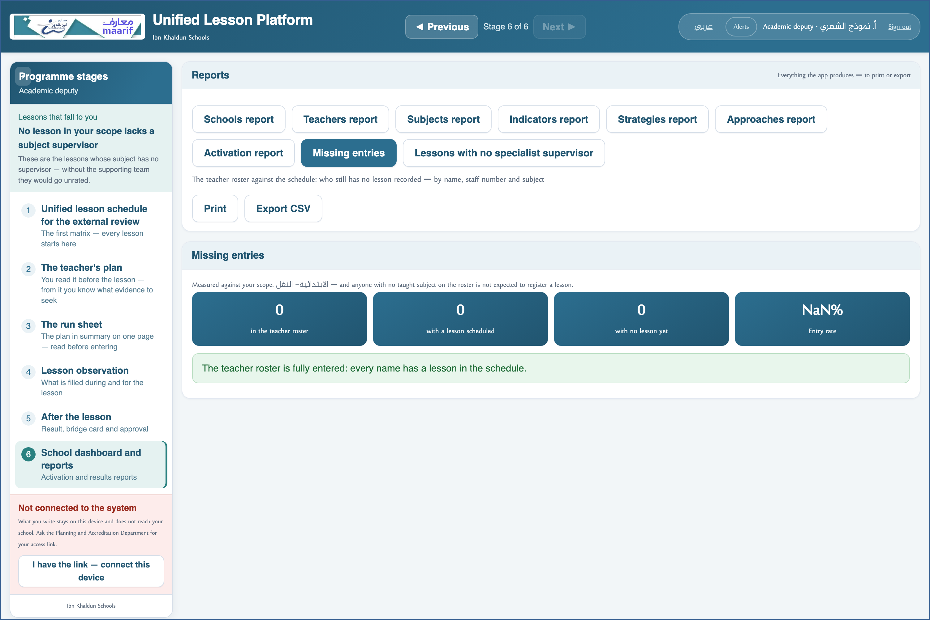
A live screenshot of the platform itself
4 Assign peers by staff number
• Open “Assign peers”: the list of your school's lessons, each with two peer slots.
• Type the staff number and the name appears from the roster to confirm — then it saves itself.
• The “Not yet assigned” filter shows you what is still without a peer.
⛔ By number, not by name: names repeat, and a teacher would see someone else's visit.

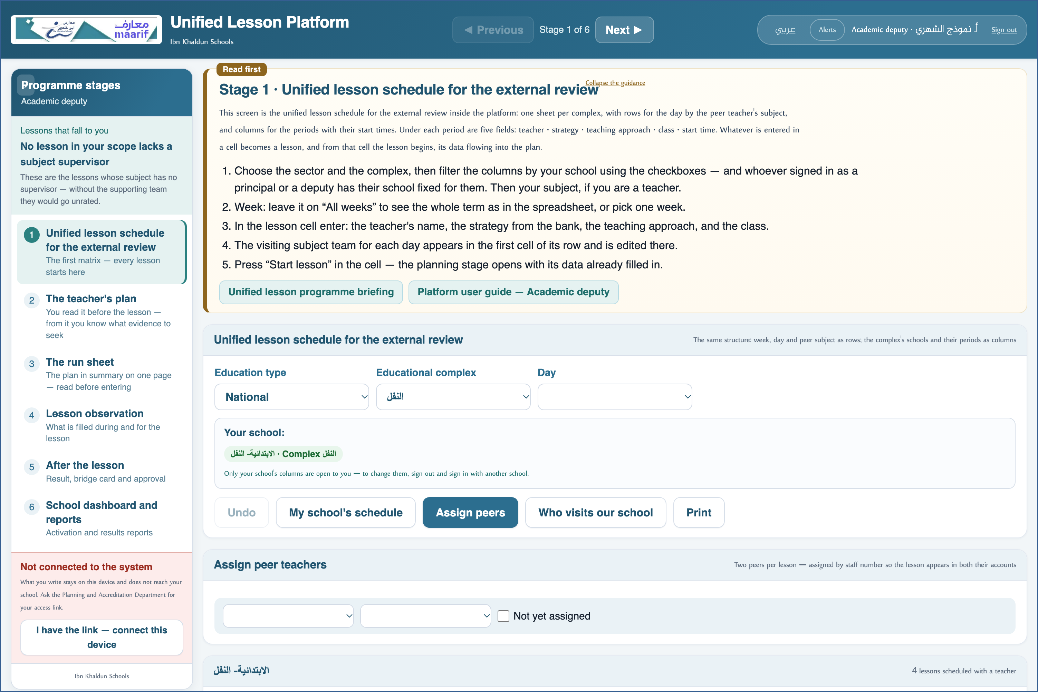
A live screenshot of the platform itself
5 Observe what concerns you
• Your capacity on the card, “Academic deputy”, is filled from your role automatically.
• Observing and approving work exactly as they do for the principal.
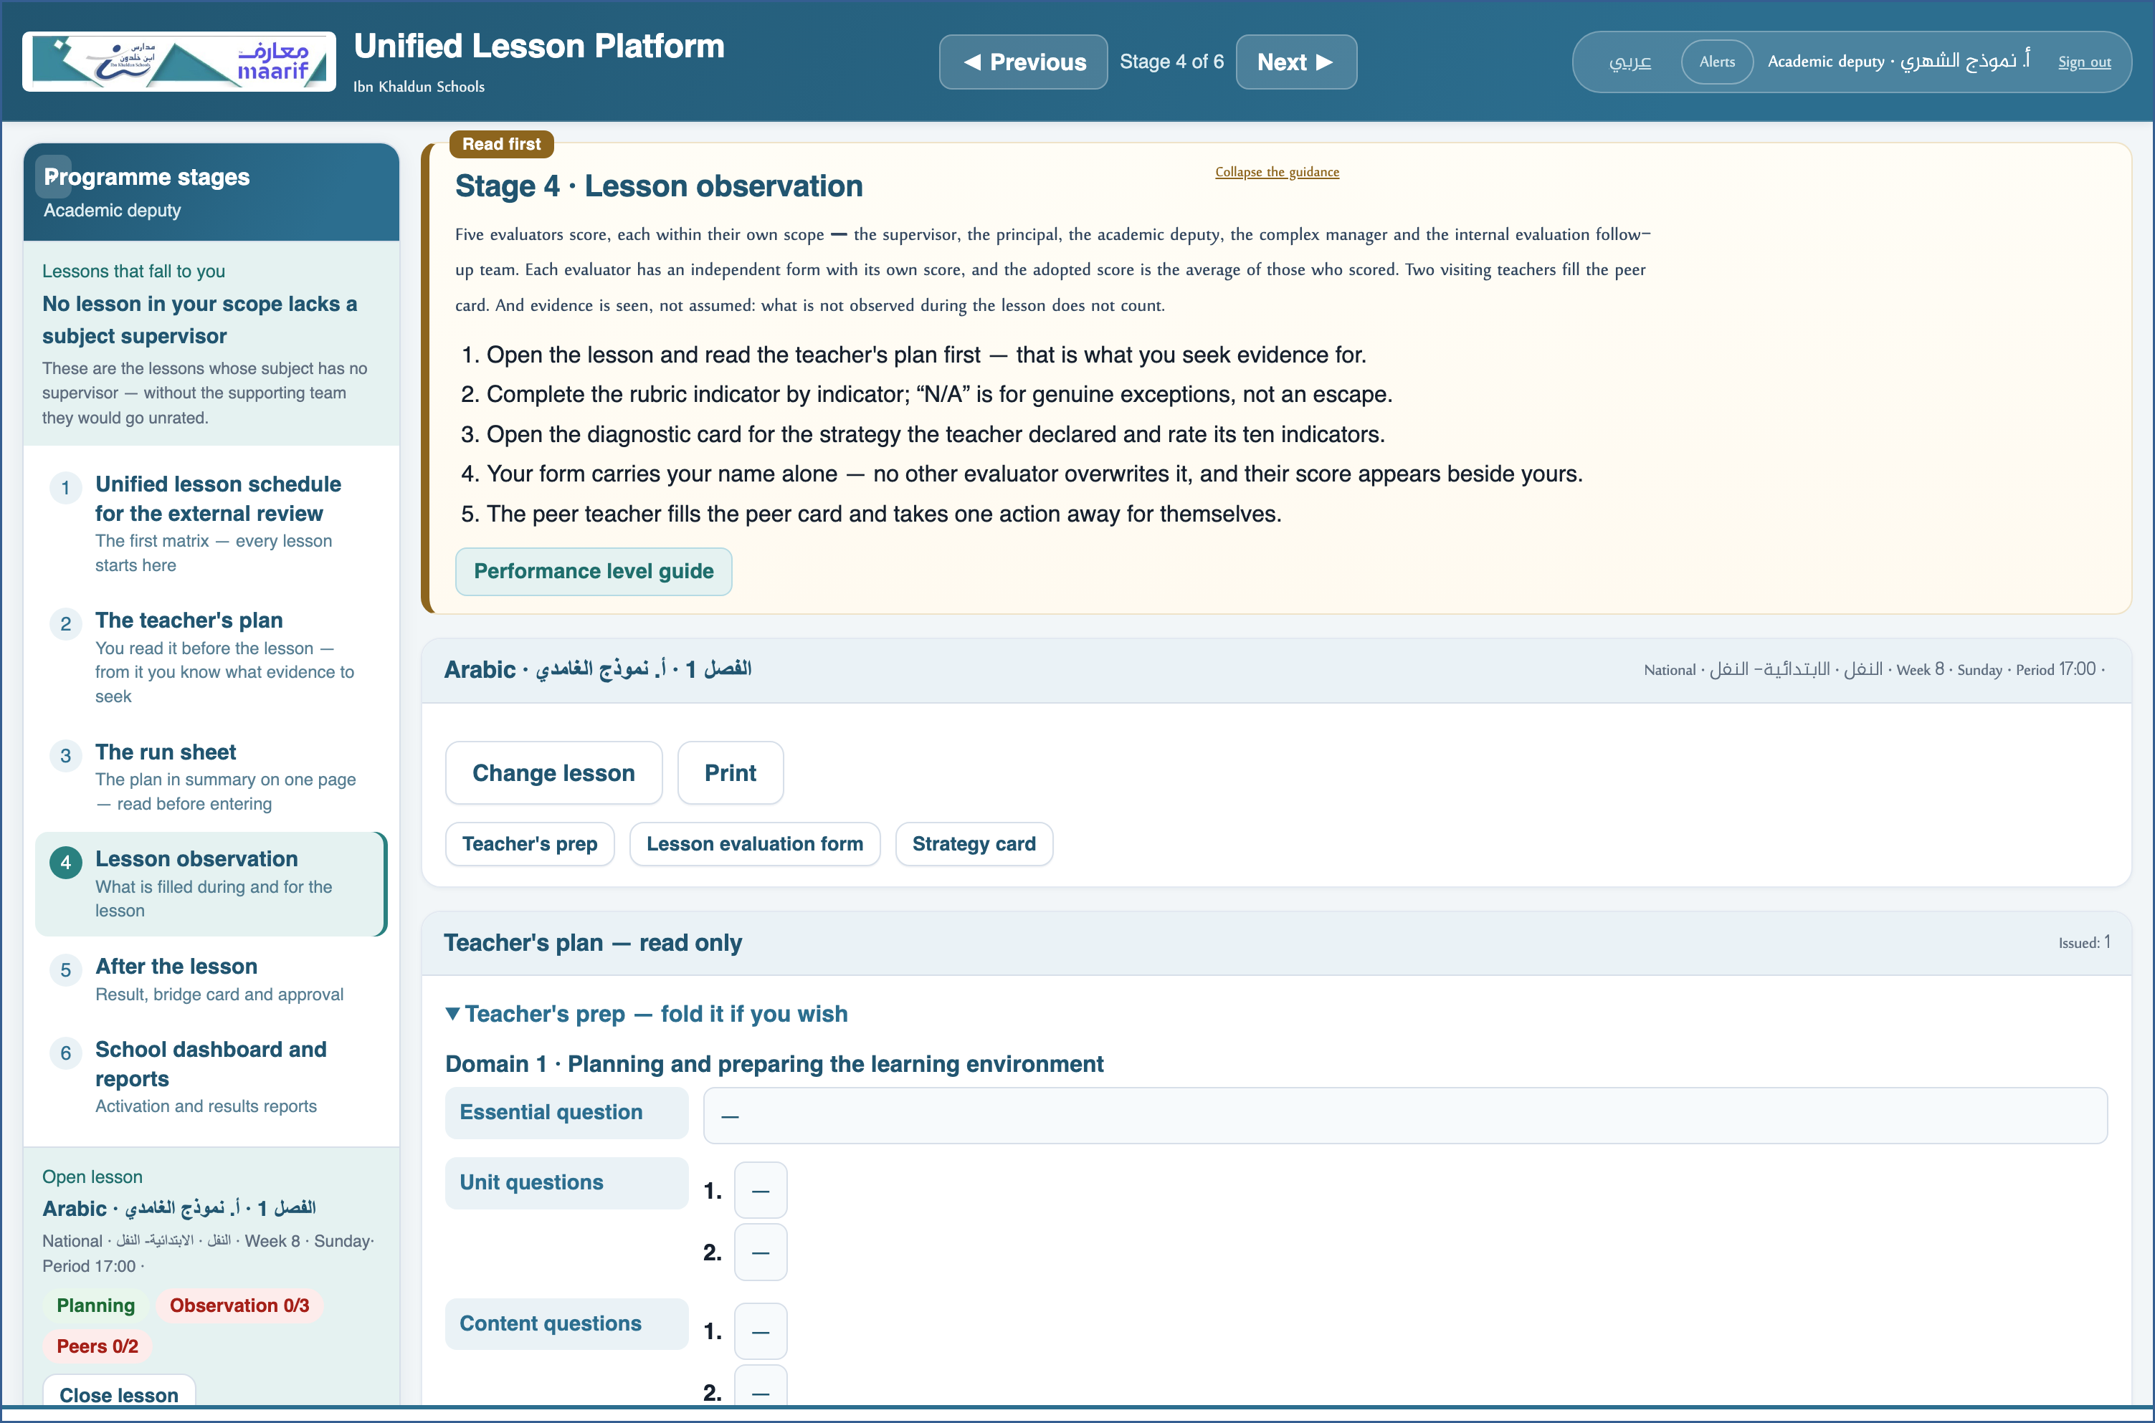
A live screenshot of the platform itself
❖ Where things usually go wrong before you ask — the most common cases
What happens | Why, and what to do
I assigned it and it did not appear for the teacher | Check they signed in with their own staff number — matching is on the number, not the name.
The number is not on the roster | The number is accepted and saved, but with no name to confirm it. Ask the Planning and Accreditation Department to update the roster.

❖ Frequently asked
Q: How many peers per lesson?
A: Two — two slots per lesson.
Q: Does the principal assign as well?
A: No. Assignment was given to you alone so a teacher is not assigned twice from two directions.
Who to contact
If what concerns you does not appear, or something that is not yours does — contact the Planning and School Accreditation Department.
If the page does not open at all — check the link above and your connection.

https://ahseyam.github.io/unified-lesson/
Planning and School Accreditation Department · Ahmed Seyam

